
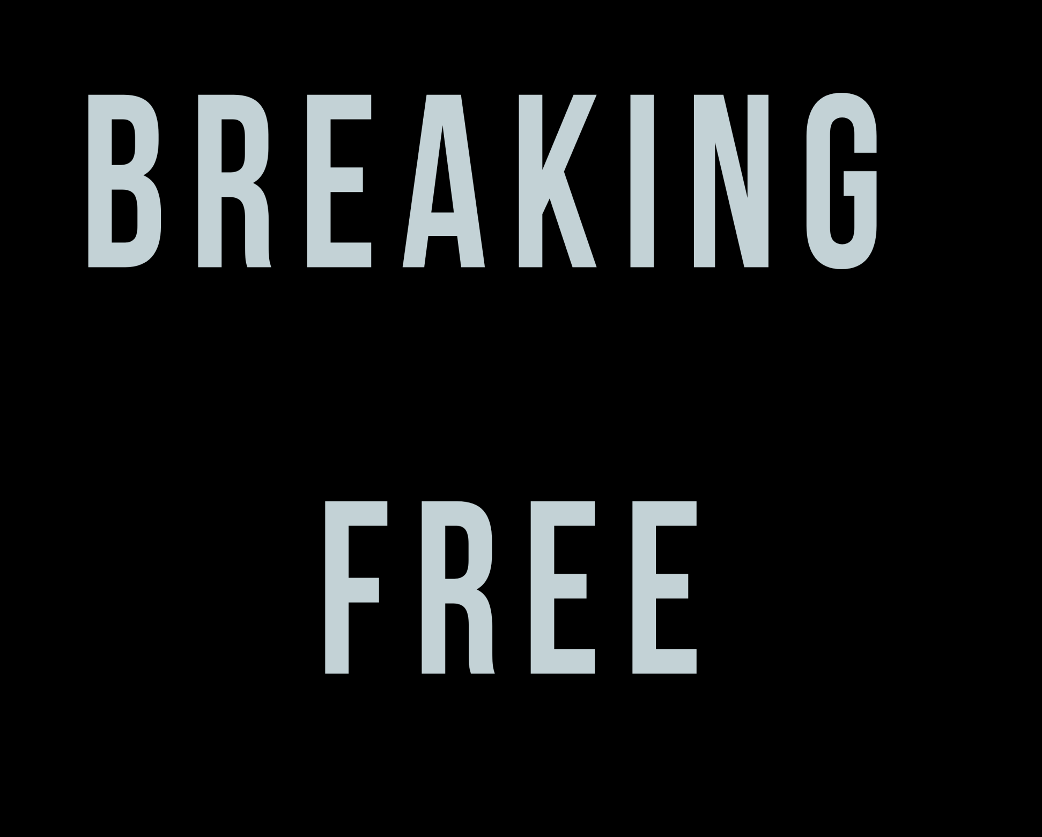


Leaving the past where it belongs

Susan Allin
CONTENTS PAGE
Introduction 2
Chapter 1 Your Present 4
Chapter 2 Your Past 12
Chapter 3 Your Future 23
Chapter 4 Getting there 27
Chapter 5 To do 45
Chapter 6 Stumbling-blocks 49
Workbook 68

Introduction

I decided to write the book I should have read 40 years ago. Weird, but true.

As a 20-year-old, I was clueless and naive, and during the subsequent decades, I kept repeating the same mistakes.

Not only that, but the wrongs done to me accumulated into a shipload full of grudges, resentments, and actual pointless bursts of anger against people from the past.

To quote Mark Twain: “I have gone through some terrible things; some of which actually happened.”

It is a pity that it took me so long to make peace with myself and my past. Many tranquil and joyful moments were stolen from me (by myself, no one else).

I am not saying I have reached Nirvana, but my episodes are short-lived and rare nowadays. And I manage to bring myself back to the appropriate mindset very quickly.

The fact that you bought this book – thank you for that – indicates that you, too, want to break free from your past and live a satisfying and fulfilling present.

The e-book is accompanied by a workbook, which you can print out or complete online. It is extremely important that you complete the exercises - otherwise, the information in the book remains cerebral knowledge and does not serve you in the practical manner it is intended to do.

Ignoring the workbook will not help you. New habits must be ingrained in your daily existence, and you need to practise.

Some of the information in this book must be attributed to various course presenters on Udemy and elsewhere, notably Graham Nicholls and Melissa Crowhurst. Thank you for your excellent lectures and practice sessions! Anthony Robbins’s “Awaken the Giant Within” has also been a valuable source of information and inspiration.

The rest is drawn from personal experience, life lessons, and relationship advice on social media.

I wish you success on your journey!

Susan Allin

Socrates: “The secret of change is to focus all of your energy not on fighting the old, but on building the new.”

Chapter 1: Your Present

Please use your workbook and write your answers to the questions asked. It is for YOUR EYES ONLY if you prefer, so be as brutally honest as you can be. But please also remember to be kind to yourself. You deserve it!

Also, if this book is to work for you, you need to REALLY examine yourself, your feelings and thoughts, and all those spaces underneath. Make this time for yourself – ignore the needs of the external world for a little – allocate an hour or more per day. It will change you, for the better, improving your mental and spiritual health, as well as making you more proactive and productive in the end.
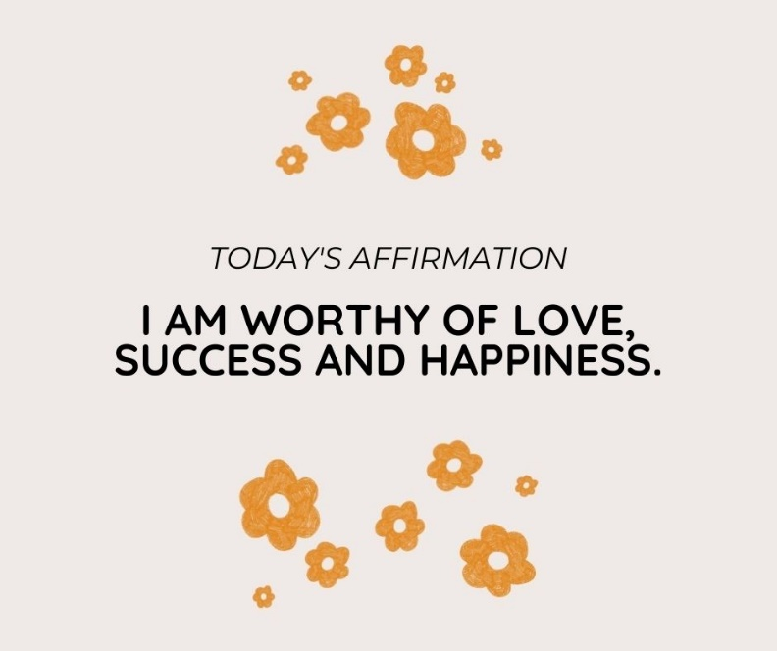

- Why did you buy this book?

Were you attracted by the title, the cover, or an emotional connection to the thought that you need to break free?

Is your past holding you back?

Are you currently experiencing issues that stem from events that took place in your childhood, or more recently?

What are you hoping this book will help you to do or become?

Make a random list – there are no right or wrong answers.

You may feel that something inside of yourself is holding you back. These are known as ‘limiting beliefs’, because they are thoughts that prevent you from achieving your full potential of happiness, success, and enjoyment of life.

We absorb information through our senses – what we see, hear, taste and feel. These experiences are transmitted to our brains and bodies, along with the emotions and thoughts that accompany these physical experiences.

Let us say you are trying to become an athlete. The physical exertion and discomfort you experience while you are still unfit, can be overcome with determination and willpower, but if you should have a person standing next to the track, repeatedly teasing or criticizing you about the fact that you are out of condition, this becomes a ‘truth’ in your mind.

You feel inadequate, especially if other athletes sprint past you with ease. It is quite natural then to decide that you will never measure up, and quit.

The opposite is also true: if you get positive encouragement from others, you will start believing in yourself, and succeed.

Therefore, it is important to surround yourself with people who are supportive. If you cannot find anyone close to you to do so, rather join a group of people who are trying to do the same as you, or go and practise where there is no one to criticize you.

Do the following exercise:

Tell the story of your life, and the issues that are causing your unhappiness, dissatisfaction or discomfort – write it, or record a movie. You will be your only audience, unless you choose to share it.
Check for words and phrases that are repetitively popping up: ‘I can’t’, ‘I won’t’, ‘He/she/they did this…’

Write these down, or highlight them. It will be useful later.

- Emotions and/or behaviours

What is bugging you most now? We are often frustrated by our current circumstances:

- Not enough money

- Unhappy job environment

- Relationship issues with family/ partner/ friends

- Physical health

- Emotional health – depression, lack of motivation …

- Living environment

- Low self-esteem

- Stress

- Anxiety

The list goes on …
Is there anything about your current behaviour or habits that are troubling you and that you would like to change?
Write it down.
Remember the following: you ARE NOT YOUR BEHAVIOUR.
In other words, if you should say, “I am lazy”, that is not who you are. It is just the way you choose to behave.

Also, all behaviour has a positive intention, even bad behaviour! ‘Being lazy’ could be an attempt to avoid doing something unpleasant, like vacuuming the carpets, or doing your filing – both activities that I detest.

A woman complained on social media about her partner acting out if his favourite sports team lost a match. He would go and trash all the food in the house!

Even though this is rather extreme, his intention was to get rid of his disappointment and frustration – which is a positive goal; just his method was inappropriate.

It would be interesting to examine his motivation for trashing the food, instead of the furniture, for example. What could be the underlying reason for that?
Why would he associate his frustration about a losing team with food?

Think about your bad behaviors and your intentions behind them. A simple example: do you use swear words when confronted with a challenge, such as bad traffic, or poor performance at school/ work/ sports? The aim is to release tension, which is good, even though the vocabulary may not gain you the respect you want.

- Dig a little deeper!

Whatever you identified under the above point, go a little further into your emotions. Is there more to it than just appearances?

Is your frustration about the traffic perhaps directed at having to go to a workplace where you are unhappy?
Is your anger at your spouse due to your frustration at work?
Is your dissatisfaction with yourself rooted in incidents from your past?

Do you drive your children to perform because you feel you have failed in life?

At my previous job, I had a situation where the department head spread lies about me. As I am a trusting person, I never suspected anything. I just saw people from management giving me hostile glances and making comments in reply to things I never said. Only with hindsight, did I realise what she had been doing.

After I had finally cottoned on to her actions, I was furious, repeatedly wishing I was into doing voodoo dolls.

Eventually, I accepted the fact that this was MY rage and that nothing I felt would change the situation. Besides, I would still have been in the same job if it hadn't been for her!

I resigned after seven years at that institution and am much happier now. As a matter of fact, I am grateful every single day that I walked out!

I should go and thank that department head.

The point I am trying to make here, is that, if you consider the real emotion, what is your issue?

To me, it was about my integrity – superficially – but truly, it was about my need for respect and acceptance.

This stems from my sense of inferiority and isolation as a child … that make sense?

I really love this quote by Wayne Dyer: “How people treat you, is their Karma. How you react, is yours.”

Referring back to your ‘life story’ from an earlier exercise – how many of the generalisations you used are actually true? Try to edit your story and change the impossibilities to possibilities.

Tony Robbins writes in his book “Awaken the Giant Within” that it is never the events of our lives, but the meaning we attach to them that shapes who we are today and who we will become tomorrow. He goes on to say that our beliefs are the guiding force to tell us what will lead to pain and what will lead to pleasure. In order to change our behaviour, we have to change our beliefs. Once accepted, our beliefs become unquestioned commands to our nervous systems, and they have the power to expand or destroy the possibilities of our present and future.

I will provide you with an example a little further on in the book.

- Which words do you use when you feel this way?

If your anger is directed at yourself, what language do you use? Are you calling yourself an idiot, stupid, or useless?

If directed at someone else, do you list all the things they did to you? I know that this was my modus operandi.

I would wish the family member or ex-colleague all kinds of awful consequences, such as, “I hope someone does the same to you!”

If you are depressed, are you saying to yourself, “I am just not good enough”?

Do you repeat words directed at you in judgment, which you have accepted as the truth? Such as, “You will never amount to anything.”

Mahatma Gandhi said, “I will not let anyone walk through my mind with their dirty feet.”

The moral of this statement is that you are allowing others’ judgments to influence your judgment of yourself.

Write down the words you use to berate yourself or others.

Also take note of your body language when you are using your negative language – are your fists clenched, are you frowning, are your shoulders slumped? Changing your physical stance can have a huge effect on your mental state.

Go on, try it!

Chapter 2: Your Past

- When did you first feel this way?

I can still hear the family member’s voice, saying, “Susan never finishes anything.”
I was about 12 years old at the time! Since then, every time I found a project I was enthusiastic about, I remembered that statement. When I lost interest, I felt that the judgment had been justified.
I was not mature enough to realize that it is OKAY to try different things until you come across the one pursuit that feels right to you.
Gradually, you start feeling like a failure every time you make a mistake or give up on a project, especially when you compare yourself to others who seem to be sailing through the situations you are struggling with.
Also, one tends to give up when the activity becomes more challenging, believing that one will be unable to finish it.
This ‘pain point’ of “Susan never finishes anything”, develops whenever the pleasant outcome is not achieved easily, making me believe that I am not capable of completing the task.
Obviously, one then goes ahead and confirms this negative, incorrect statement whenever one finds that one is not conforming to society’s expectations. It took me a lot of introspection and self-analysis to find out where exactly I had lost direction.
Bill Gates said, “It’s fine to celebrate success, but it is more important to heed the lessons of failure.”
It is actually important to make mistakes! That is the biggest learning curve one can experience. What went wrong, and why? You can ask yourself this question, and through doing this you discover how to do it right the next time, or the next, or the next.
Thomas Edison, who invented electricity, said, “I have not failed. I’ve just found 10,000 ways that won’t work.”
Yep, 10,000 failures before he created one of the biggest inventions of the modern world!
Referring to the title of this book, “Breaking free”, I would like to include this quote by Mahatma Gandhi: “Freedom is not worth having if it does not include the freedom to make mistakes.”
NOTE: NEVER compare yourself to others! As a writer from the 17th century said: ‘If you compare yourself with others, you may become vain and bitter; for always there will be greater and lesser persons than yourself.’
As an artist, I am often tempted to compare my artworks to those of my peers, and I often feel that my works are not as good as theirs, especially if they sell at an exhibition and I don’t.
I then remind myself of my own advice to my Design students: ‘Only compare yourself to yourself. See how much progress you have made from last year until now. Keep your first attempts, then notice how much you have grown.’
To quote Matty Mullins: “The only person you should strive to be better than, is the person you were yesterday.”
Robbins often refers to pain points and pleasure points. The human nature is such that it avoids pain and seeks out pleasure.
That which gives me pleasure, also becomes a pain point, as the inner critic pops out and tells me that the painting I am doing, is not ‘good enough’’, ‘will not sell’, or some such garbage. The general idea is to turn your pain points into pleasure points.
After all, if you cannot believe in yourself, how many others will?
- What or who reinforced this feeling?

Subconsciously, I chose partners who reinforced my feelings of inadequacy – alcoholic abusers who made me feel useless and insignificant. I patterned them on the model of the criticizing family member, not realizing that this was what I was doing.
Why on earth would one do such a thing?
There could be several reasons: I felt familiar with such behaviour; I could be hoping that this person would change into a caring, loving person and so change the past; I may have believed that this was what I deserved …
I allowed external forces to shape my inner perception of myself.
I felt insignificant and undeserving, not realizing that the abusers were actually the ones who felt inadequate, which was why they tried to make me feel small.

In Mark Twain’s words: “Keep away from people who try to belittle your ambitions. Small people always do that, but the really great make you feel that you, too, can become great.”

You can resolve it only when you become aware of your own negative thoughts about yourself, examine the source, and consciously change your behavior and mind patterns. Go back and look at your life story that you wrote or filmed earlier. Look at the words you used, which limited your beliefs.

Write down what you believe the origin of your feelings to be. Ask yourself – is this really true about you? (Hint: The answer is a resounding NO!)

We lie to ourselves: we do not deserve the things we want in life; we are not worthy of success; we are not loveable.

We DO deserve the life we want; we ARE worthy of being who we want to be; we DO all deserve love.
To quote Tony Robbins again: “Complacency breeds stagnation.”
Everything you want is on the other side of fear. If you haven’t been afraid; if you haven’t experienced pain, you have missed out on opportunities to grow. Loss, fear, and pain are hugely uncomfortable while you are experiencing them, but the person who emerges from the other side (and emerge you do) is a person with a stronger resolve, more resilience and an emotional backbone.
That is, if you choose to be so. Because your response to negative experiences is YOUR choice. You may find that I tend to repeat myself on this point.
In the words of Eleanor Roosevelt: “No one can make you feel inferior without your consent.” Profound words.
Something I learned recently through an art course I was doing, is that we all have an inner critic, with whom we should build a relationship. What is your relationship with your inner critic? If it is poor, it is time that you mend it. Treat your inner critic like a person living inside of you. Form a mental picture of him or her, and have a conversation with it. Try to find out what the reasons are for the criticism, try to make buddies with him or her.
Remember to listen to your heart, not your brain. Your brain lies to you, telling you that you don’t measure up.

- Which words can you use to replace these feelings?

First, think of who/ what triggered your first negative beliefs about yourself. Was it a friend? A parent? A sibling?

Where is that person now? Would you accept the same words from that person today?

Remember: no one is broken, and no one needs fixing. This means that people are fine, but may have poor strategies for life, or are carrying out those strategies poorly.

Consider carefully where you are now. By studying this book, and doing the exercises, you are making a conscious effort to change, or improve, your state of mind and your life.
Robbins has developed a technique whereby one can do a mind shift through changing your vocabulary. Even if the situation is one that drives you to fury, translate this into terminology such as, “This is rather peeving.” Immediately the situation is turned from being ‘infuriating’, making our blood vessels pound, to a little incident, hardly worthy of notice. Also ask yourself, How can I use this for my own self-improvement, or for improving my business?

Write down your original, negative perspective, which was instilled in you, and write down a positive statement to replace it.

Let us take mine: Susan never finishes anything.
Positive statement: Susan decides which projects are not worth finishing and moves on to those that are.

Negative statement: I am not good enough.
Positive: Hell, yes! I am good enough! (Then list your achievements, no matter how small.)
Greg Henry Quinn said: ”No matter how small, acknowledge the achievement.”
The acknowledgment of your achievements may not have penetrated yet, because a habit of negative thoughts has been ingrained.
Rewrite your negative statement as a positive one.
Let us continue working through this. There is more to come!
If the memories this exercise evokes are painful, let us stop here for a moment and work through them.

Sit comfortably, maybe turn on some meditative music, and breathe deeply for a minute or two. Close your eyes and visualize that event or moment which triggered your negative beliefs as if it is a movie you are watching on a screen.

Gradually the picture becomes smaller and blurrier ….
Take your time with this exercise. You may even have to repeat it several times. Eventually, you reach out and turn the screen off.

If you feel you need to repeat this exercise, don’t do it on the same day. Space it out, as it could be emotionally exhausting, depending on how traumatic your experience was.

If you find it difficult to do this on your own, you may need the assistance of a therapist.
If you would like to contact me for an online session, you can email me at susantrautallin@gmail.com, or book an appointment at https://calendly.com/indigotherapycentre/life-coaching-therapy-counselling.

- Find your identity
Ask the question: ‘Who am I?’ The answer should NOT be: ‘a father, a housewife, a daughter, a teacher, etc.’ Who do you perceive yourself to be, as a person? For example, ‘I am creative, intelligent, honest, caring, and so forth.’ That is your identity.

Where you are at the present moment in your life, is where your personal standards have allowed you to be.

Your second question is: ‘What am I?’ That would be ‘I am a writer, a mother, a business owner …’

How do you choose to live? With focus, integrity, joy, love, discipline, ambition – you decide. What, in your life, are you no longer willing to accept?

Who am I willing to become? Make your identity statement, print or write it out. Place it somewhere where you can see it daily.

EXAMPLE: I, Susan Allin, am a creative, intelligent, loving wife, mother, teacher, writer and artist, who chooses to live with focus, integrity and joy, and I am willing to become a better version of myself each day, so that I may serve my purpose and achieve my goals.

- Your support team

There are very few people in the world who are truly alone, without anyone or anything to support them. Even Buddhist monks have their beliefs and fellow monks to back them up.

If you find yourself to be isolated from the world around you, your family, and no friends, it is up to you to change that, if you want to. Reach out and contact someone who needs your help – the beggar on the street corner, the old lady crossing the street, or a neighbour.

Many people are too proud to reach out and ask for help. The self-created illusion is that people will look down on you if you should do so; that you will appear to be dependent and unable to run your own life.

That is a lie that your mind tells you. Unless those around you are truly dysfunctional, they would love to assist. Sometimes, because you are too proud to ask, they believe that you are absolutely fine, and that you don’t need their help, or that you hate them and don’t want them nearby.

Consider the message you are sending.

There was a period of about seven years during which I had no contact with my family. I had the perception that they had rejected me. Being in a relationship with a narcissist who encouraged me to cling to my negative thoughts, I was isolated from people who loved and cared for me.

Once I realised that I was repeating a pattern from previous abusive situations, I managed to break free from that person. It took too long for me to become more assertive and boot him out of my life (and my children’s).

I managed to be present at my father’s deathbed, surrounded by my sisters and my children. I could talk to him before he died and could find peace in his peace.

Think about and make a list of the people in your life. A spouse, partner, friends, family, colleagues, classmates – write down the list of people that surround you. It does not mean that you will have to ask anything from them, but maybe you could look at their needs and personalities. What is it about them that you like, love, dislike? How do they influence you, if at all? How have they influenced you in the past? How can you give of yourself to them?

Interestingly enough, I read somewhere, that, when a person annoys you, it is someone whom you resemble, or who has traits that are similar to yours. It often works that way in families, too. A parent and a child who have characteristics in common, seem to clash most often. This is not a scientific statement, just a personal observation.

One is always told to prioritise. So, one prioritises. Which task is urgency number one, etc.

During the later years of my career, I came to realise the following: if I should die overnight, no matter how hard I had worked, I would be replaced immediately, or soonest. My employers would have kind and soothing words (I hope), but the business has to carry on.

Your children, spouse, parents and siblings, however, are the ones who cannot replace you.

Prioritise those relationships. There may always be another job, another opportunity you can create for yourself. There is only one family, though.

I read somewhere that the only people who will remember that you had to send that urgent work-related e-mail on a weekend, would be your family.

Nurture them. If you have a truly grotty family, well, firstly, pat yourself on the back that you have turned out so well; then ensure that you have done everything in your power to build a relationship. If that is not possible, seek guidance, and move on.

Chapter 3: Your Future

- Visualize your perfect self.

Close your eyes and breathe deeply. Picture yourself 10 years (choose your own timespan) from now.

You have achieved the state of being, success, or happiness you have wanted.

How does it feel?

Visualize your environment. Where are you? In your dream house at the coast? Painting in Paris? Is it day or night? Is it sunny, is the wind blowing? Make it real! What color is the house? Walk through it and see the floor, walls, rooms – every little detail. The views from the windows, the color of the curtains …

It does not have to be a physical object. It could be an achievement or an activity: skiing in the Alps, winning the Comrades Marathon, becoming a Barcelona soccer player, getting your degree - anything that you dream of.

Which emotions are you experiencing?
Who are with you?
See the people around you, if there are any. Hear them talking; imagine them looking at you with admiration and respect. Immerse yourself in the moment.

Remember, if you start visualizing realities that have not come true yet, your vibrations and the energy of the universe align to make your dreams come true.

Subconsciously, or even consciously, you start acting towards the fulfillment of your dream. You start noticing opportunities; events matching your thoughts start popping up on TV, on the side of a bus, or on social media.

“We become what we think about.” Earl Nightingale
"You must find the place inside of you where nothing is impossible" - Deepak Chopra

- List your dreams.

Make a list of all the things you dream of having, or the person you dream of being.

Imagine that at that point in the future where you are now, you have achieved all of that. It does not matter how silly or insignificant you may think it is, write it down.

Draw three columns or use the diagram in the workbook. Ask yourself: What do I REALLY want?

COLUMN 1: THINGS, such as a house, car, money in the bank – anything material

COLUMN 2: PERSONAL, e.g., health, excitement, adventure, family, love – more emotional stuff.

COLUMN 3: OPPORTUNITIES, like career, experiences, contributions to society – public success.

Also, write down the reasons why you want these. Select one (or more) from each column and describe them in detail.

How would having these dreams fulfilled add to your life?

- How do you feel about yourself?

How do you feel about yourself in your visualized environment now that you have achieved everything you have ever wanted? Proud? Contented? Happy?
What will your life look like if you do NOT achieve that? How would you feel?
What would be the effect on your dreams and aspirations?
Having had the vision of the future, do you think that not achieving your dreams is an option?
So, what is stopping you?

CHAPTER 4: GETTING THERE

- Back to the present

Now, let us return to where you are now. What do you think of the future YOU? Do you like it? Is it possible?

Of course, it is! I never thought that I would EVER write a motivational book, but here I am, writing a motivational book.

A little bit of inspiration:

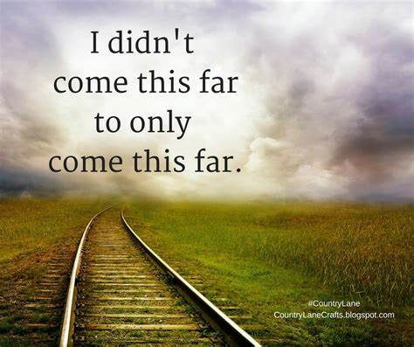

What do you think of your present self? Would you like to get to that future self?

So, we are going to jump a few more hurdles before we get there. Well, sometimes we don’t feel like jumping, so we will then just crawl through them.

Here is another exercise for you, just to help you clarify where exactly you are at the present moment. A blank version is provided in the workbook, or you can create your own. I have completed an example of what it could look like when you are done. This exercise I got from the Life Coaching course, presented by Graham Nicholls.

On the graph, complete the “spokes” of the wheel to indicate how satisfied you are in each of the different areas of your life – this is my personal one. Choose your own areas to complete the diagram. The fuller the slice of the pie is, the more fulfilled you are in that area.

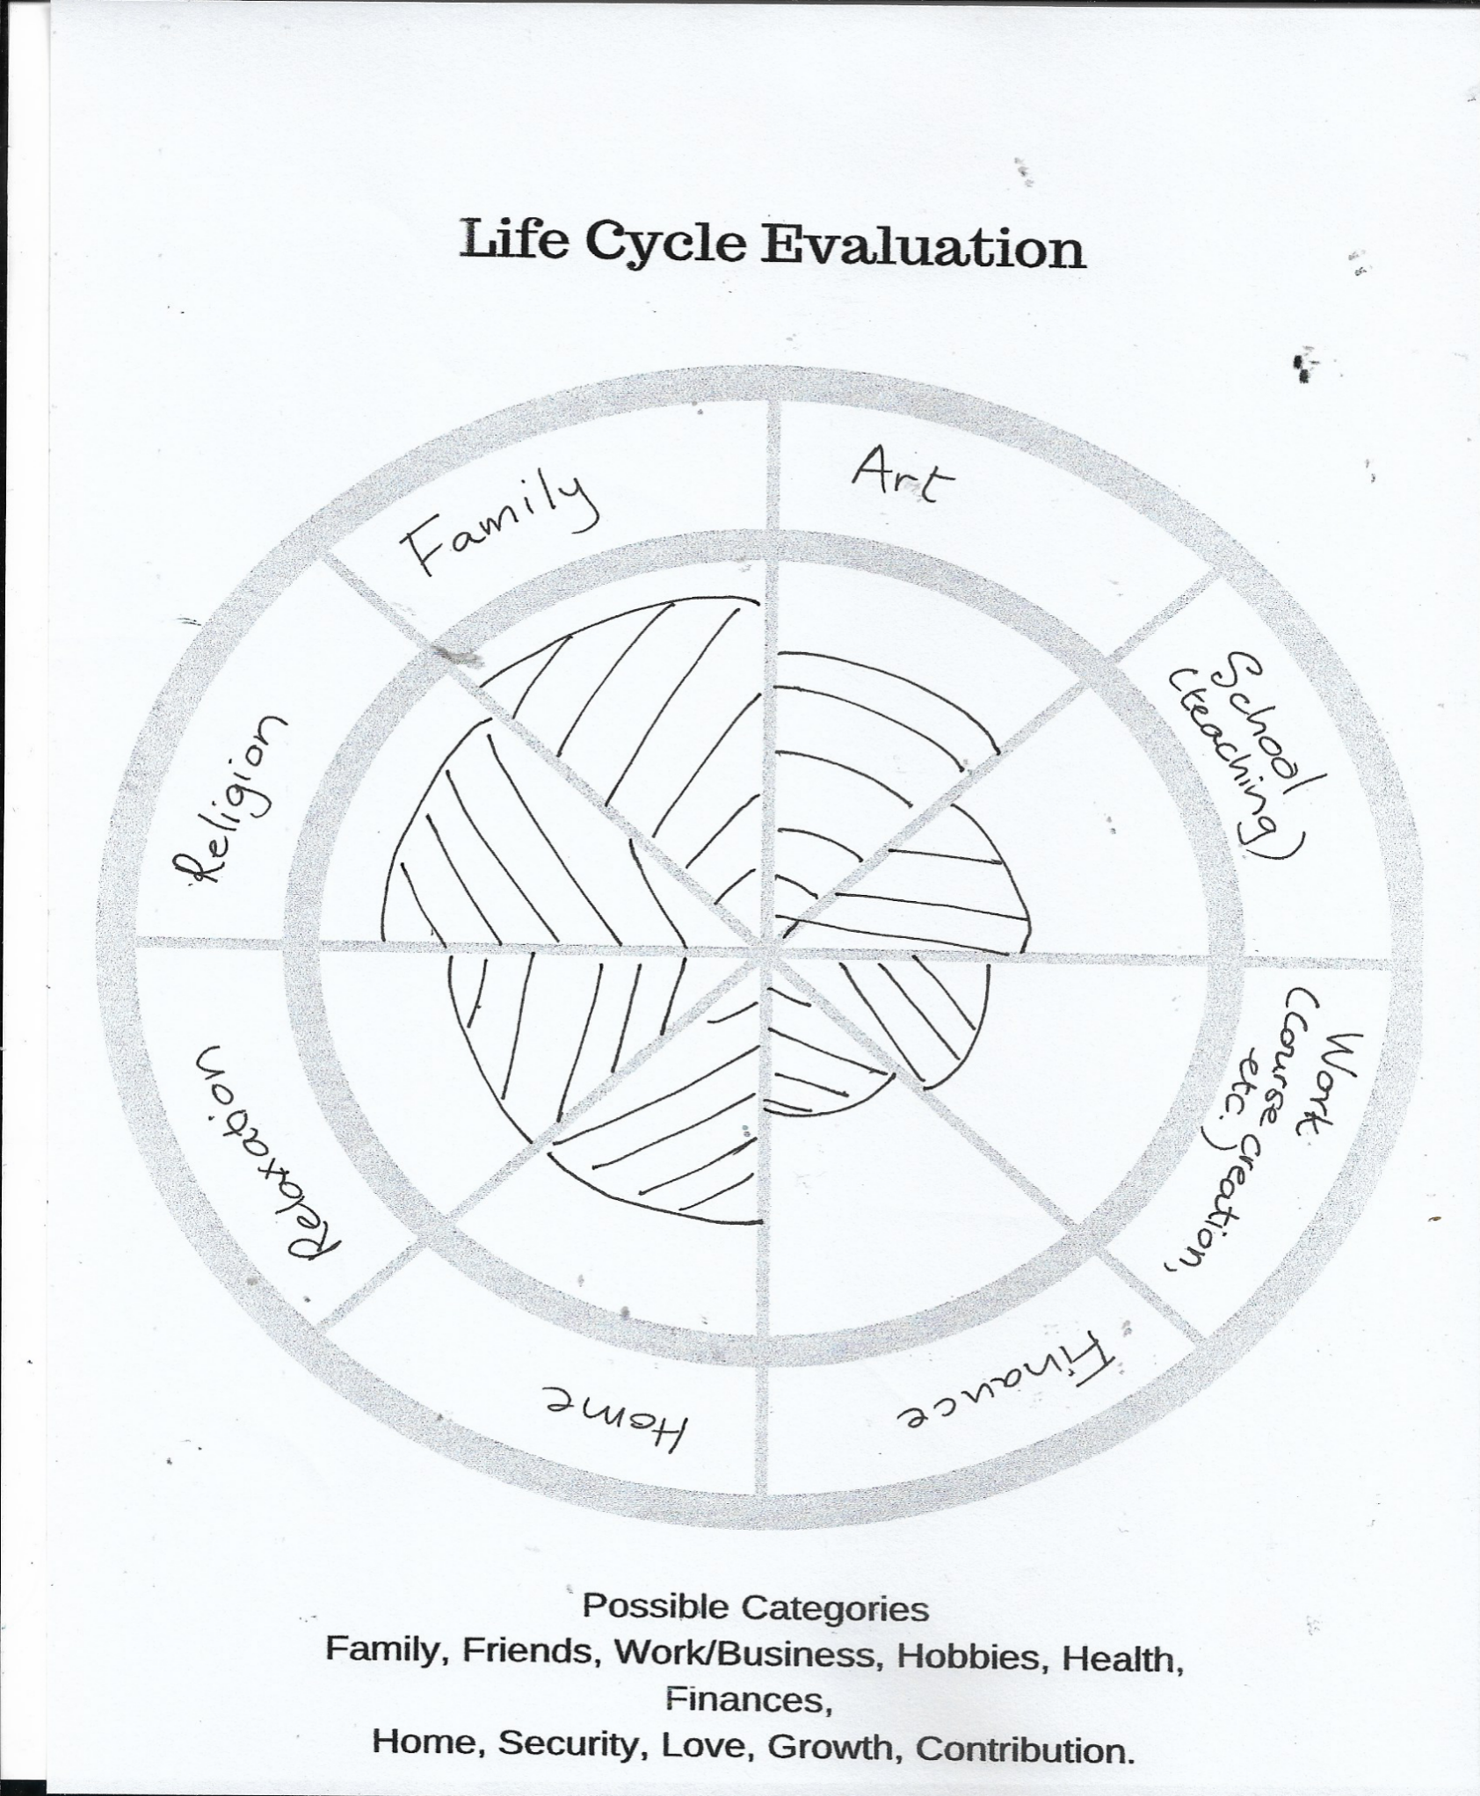

Allocate a score out of 10 for each of these categories, and rank them from the lowest to the highest.

My lowest is definitely Finances, so that would rank number 1 on my list.

Once you have done this, decide what your options are for improving this. Why is this the lowest on your list?

Mine, for example, is that I spend a lot of time on activities that do not produce enough income, which takes my focus away from activities that could generate more income. I am always busy, but I tend to shy away from that pain point moment, which could just have been my breakthrough,

Ask yourself, how are you going to change this? What do you need to do?

I will provide a guideline on the questions you need to answer, in the workbook.

- What is holding you back?

I speak from experience when I say that if there is a problem for every solution, I have found each one.

‘I can’t resign from my job, because I need to pay the rent.’ ‘I don’t have the money.’ ‘I don’t have time.’

Instead of saying, “I can’t ….”, ask yourself the question: “How can I …?”

The truth is that you have all the resources you need. You just need to plan it out. Yes, you do! Don’t argue; just stay with me here.

The biggest obstacles are usually: fear of failure and fear of success. Fear of failure is obvious because you feel like a failure if you make mistakes. Just remember once again: YOU ARE NOT YOUR BEHAVIOUR: you are not a failure if you make mistakes.

Graham Nicholls, in his lectures on Neuro-Linguistic Programming, states the following: “There is no such thing as Failure, only results that you weren’t expecting. There is also no such thing as success, only results that you hope for.”

Fear of success? I’ll use myself as an example again. I am such a perfect example.

I have completed six therapy courses and am almost finished with another. Do I have clients queuing up to make use of my expertise?

No! Why not?

I am so scared of that first client making a booking. What if I don’t do it right? I haven’t practised enough! I need more courses!

This book may be the bridge I need to cross to gain that confidence.

UPDATE: I have my first client two weeks into writing this book! Whoop!

And the session went so well, she booked another appointment two days from now.

UPDATE 2: She called me an angel and booked herself into a centre for intensive therapy!

Dr Joyce Brothers made the following statement: “The person interested in success has to learn to view failure as a healthy inevitable of the process of getting to the top.”

- What can I do now to achieve that?



First, change your mindset. Tell yourself you can, and you will. Eventually, you will start believing in yourself.

I have a little piece of paper on my wall saying, “NO LIMITATIONS”. The only limitations we have, are the ones we create for ourselves.
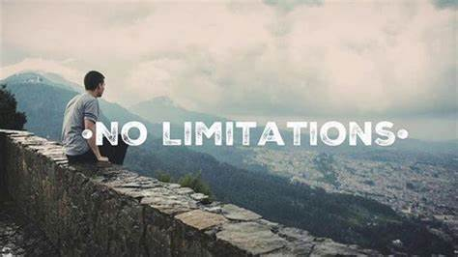

Second, start planning on paper—more about that in the next section. For now, just jot down ideas, make mind maps, research ideas, cut out pictures, and make a vision board.

Use the dreams listing from the previous chapter to inspire your search. Chunk it down into little steps and tick them off as little successes.

This is an amazing way of making your dreams concrete.

The vision board: Use a sheet of polystyrene, canvas board, felt board, poster paper, or whatever suits your fancy or your budget.

Find pictures from magazines, print them out from your computer, and use pamphlets or brochures, inspirational quotes, or words that speak to you. Cut them out and paste them onto your board. Place the board somewhere you will see it every day and take time to look at it for about two minutes every morning and evening. Don’t just look: visualize each of those becoming reality.

I can assure you; it works! Within three months of doing this exercise, I could cross off about four of the items on my board. And these ‘fulfilments’ do not always happen in the ways expected. By getting my first client, I have removed a fifth goal from my vision board.

For example, I wanted a new laptop. The one I wanted cost far more than I would be able to afford. A month after setting up the vision board, someone gifted me with an almost brand-new laptop and an extra-large screen.

I wanted my husband and I to go on a short holiday, but we could not afford it. Then, my son from overseas let us know he had booked a house at a seaside resort and invited us to join – free of charge!

I am still waiting for the R100 million, though.

Here is a brilliant story, posted on LinkedIn by Matt Schnuck:

The sting of humiliation by an asshole launched a cookie empire.
Her insight (and how you can use it):
Before Mrs. Fields created a cookie empire, she was not an entrepreneur.
Debbie Fields initially worked as a ball girl for the Oakland As. Then after getting married, she described herself as a “happy housewife”. Her husband ran a small investment firm but it was an encounter with one of his clients that would change everything.
Mrs. Fields tells the story:
“One night we went to dinner at the beautiful, intimidating home of one of my husband’s clients. This man asked me, ‘What do you do?’
‘Oh,’ I replied, ‘I’m just trying to get orientated.’
He got up, pulled an enormous, leather-bound dictionary off the shelf, put it in my lap and told me, ‘The word is oriented. If you can’t speak the English language, you shouldn’t speak at all.’
Incredibly embarrassed, sitting there in his library with tears streaming down my cheeks, I realized I wanted to be somebody. I could hear my father’s voice telling me that wealth was doing what you loved, and what I loved was cookies. So, that night, I gathered myself together and set out to become a somebody.”
And she did just that. Mrs. Fields would go on to build a cookie chain with 250 locations and amass a 9-figure net worth.
Old way:
Stunned into inaction by rude and callous comments
New way:
Channel humiliation into purpose and action.
Takeaway:
Humiliation is painful, but it does not take away your power to decide how to respond.
As Victor Frankl wrote:
“Between stimulus and response, there is a space. In that space is our power to choose our response. In our response lies our growth and our freedom.”
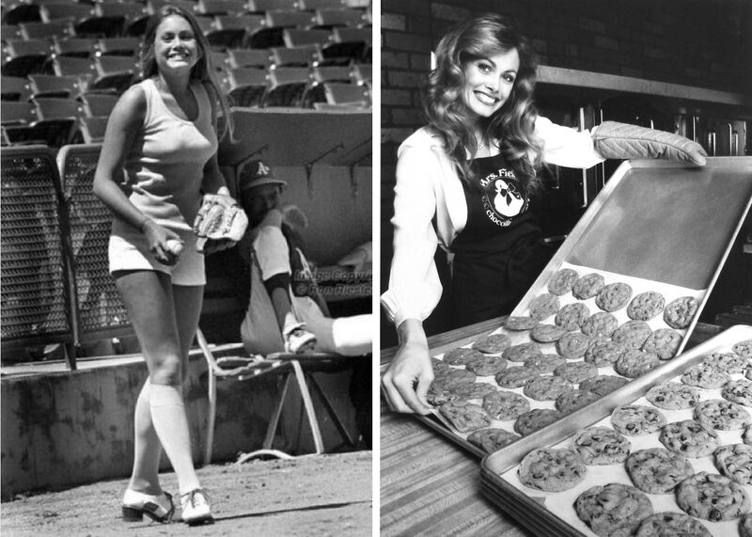

- Setting goals

I am sure you have heard of the SMART goals, but, if not, here they are. If you have, this is a reminder. Write your goal down in the present tense, as if you have already achieved it.

Believe it or not; this actually comes from the Bible (Mark 11:24)!
I quote: “For this reason I tell you: When you pray and ask for something, believe that you have received it, and you will be given whatever you ask for.”
Here is an example:
S – Specific: I have established a therapy practice with 1,000 clients.

M – Measurable: I am earning $100,000 per month. Can you measure your progress?

A – Achievable: It could be, depending on my marketing strategy, and how much time I spend on recruiting clients.

R – Realistic: If you do your proper research on the market, using Google Search engines, for example, it is quite possible to achieve this. You will just have to work your butt off!

T – Time-specific: It is December 2023

Your goal should now read: It is December 20… and I have established a therapy practice with 1,000 clients, earning $100,000 per month.

Make a list of steps you need to take in order to fulfill your goal. Chunk it down into monthly, weekly and daily steps.

Have target dates. Tick them off when you have completed them.

I have provided a form, which you could download and use, or alter in any way that suits you.
To quote Tony Robbins again: “Goals are dreams with a deadline.”
To play devil’s advocate – some life coaches advise against goal-setting!
According to this viewpoint, people tend to focus entirely on a particular goal, and often have a sense of anti-climax and aimlessness once it has been reached. There is definite truth in this, so one has to ensure that one does not single-mindedly pursue one goal to the exclusion of everything else.
I like to have several projects running simultaneously. Currently, besides writing this book, I am making vegan cheeses, I teach, I paint, I study various therapy courses, I create courses …
This is not necessarily all good, as these activities sometimes interfere with one another. I have now worked out a roster on a monthly planner, and stick to it as far as possible, even adding in extra activities if I have the time and energy.
I give you an example of how I went about it, below. It is entirely your own choice as to how you wish to structure it, but the concept gives me so much more focus and motivation.
I used to get to my office with this overwhelmed feeling of, “Ok, where do I start?”

With the help of one of Graham Nicholls’ courses, I managed to eliminate the fiction from my story, and get to the fact: I want money. I want enough for both my husband and I to retire in comfort. For the past number of years, I have been fooling myself that I was working towards that, but the moment things become uncomfortable, I distract myself from making a breakthrough. Whenever it gets difficult, such as setting up a website, I avoid the issue. I find excuses not to do it.
I have decided that this is IT! I am doing this right here, right now. No more excuses, procrastination, evasion.
So I sat down, made a list of all my activities, indicating whether they are ONGOING or LIMITED.
You will find a blank copy of this table in the workbook.

Example:
 | ACTIVITY/PROJECT | ONGOING | LIMITED
1 | Art | √
2 | Studying Reiki |  | By Dec 2023
3 | Teaching | √
Then I broke these activities down into smaller categories, e.g.
- Art: a. Paint 6x per week
- Post to social media 5x per week
- Website monthly
- Exhibition monthly
- Etsy shop monthly

- Studying Reiki: a. Revise symbols once-off
b. Revise method once-off
c. Do hands-on 4x
d. Course completion once-off

3. Teaching: a. Planning weekly & annually
b. Teaching 3x per week
c. Invoicing 23rd of each month
For the sake of brevity, I allocated codes to each activity, based on their numbers. For example, 1a refers to Art – Painting, 3c Teaching – Invoicing.
After this, I scheduled these activities onto a monthly planner. (I can assure you that this entire exercise took me less than an hour). I only started doing this on 12 November, which is why the first half of the month is blank. I will provide you with a blank monthly planner in the workbook.
I did not fill in all the entries, but I reckon you get the general idea.

Example:
MONTH PLANNER: NOVEMBER 2023
Sun |  | 5 | 12  1a, 1b | 19 | 26
Mon |  | 6 | 13  1a, 1b, 3a | 20 | 27
Tues |  | 7 | 14  1a, 1b | 21 | 28
Wednes | 1 | 8 | 15 | 22 | 29
Thurs | 2 | 9 | 16 | 23  3c | 30
Fri | 3 | 10 | 17 | 24
Sat | 4 | 11 | 18 | 25

This makes it easy for you to see at a glance what is scheduled for each day.
I used to get into my office in the mornings and just felt overwhelmed by all the work I had created for myself. I didn’t know where to start, what to tackle first, to ‘prioritise’.
Using this method allows me to allocate my time productively, and have time to relax, too.
A cautionary note: If you have started your plan of action, be careful that it does not just become one of ‘ticking boxes’, where you think that completing the set tasks for the day will bring you success.
It has to be intentional action, seeing the end goal every time. Focus on the purpose of your actions; not just the actions themselves.
Visualise the results, constantly. I am preaching to myself, here.

CHAPTER 5: TO DO

Now, this is the difficult part. We have all developed certain habits throughout our lifetimes. Some good, some bad.

We need to separate ‘habits’ from ‘routines’. Routines are those things that give us shortcuts to our daily lives, such as brushing our teeth, driving to work, and so forth.

Habits are behaviours that give us comfort or make us uneasy. A habit of exercise, which has become a routine, is usually good. When it involves the habit of using steroids, it becomes unhealthy.

Addictions are examples of habits that may harm you. Even an addiction to something that may seem good, could become unhealthy.

An example of this could be working. One can become so addicted to being busy working at something, that you don’t know when to stop and take time for yourself and your loved ones.

You become like the hamster on the wheel that doesn’t ever stop running – as a result, you develop physical illnesses, such as ulcers, headaches, and even cancer!

My sister was diagnosed with leukemia in her late forties, due to her stress resulting from a terrible divorce, financial worries, and overwork. Fortunately, she recovered and has now been in remission until at present.

I have had teenage students suffering from depression and anxiety, telling me that their doctors had advised them to smoke.

Whether the doctors had really said so or not, I believe that smoking would not prevent a depressed teenager from committing suicide, or from being anxious. Besides, smoking could even aggravate anxiety – if you are on a seven-hour flight, going without a cigarette could cause severe agitation. It is a dependency, which is not a positive resolution to an emotional issue.

This is not a judgment of smokers, because I smoked for many years, even throughout one pregnancy.

A better approach could have been advising meditation, exercise and/ or breathing exercises.

It is difficult to change an ingrained habit and easy to acquire one. The way to a healthy lifestyle is sometimes difficult and needs self-discipline, whereas a bad habit is often just an easy shortcut to the results or rewards you want. A person is attracted to the pleasure point of these shortcuts, whereas self-discipline often tends to be more of a pain point.

An example of this could be over-eating when you are going through a tough time, or drinking too much in order to relax.

STEP 1: Identify your bad habit(s). Be honest with yourself. Face the facts. Do I ‘eat too much’, or do I ‘have a drinking problem.’

STEP 2: Identify when/why/how you practise it. Is there a specific time when you feel the need to behave the way you do, or are there specific emotional or physical triggers?

STEP 3: What do you wish to achieve by doing this? What is the positive outcome you want?

STEP 4: How does the practice of this (bad habit) make you feel?

STEP 5: Are there any other options for this habit to gain the feelings you want? Look for alternative behaviours that could give you the same emotional result.

STEP 6: Which reminders are you going to put in place whenever you feel like practicing this habit? Example: a sticker of a slim and trim person on the fridge, to prevent you from grabbing that piece of tart. (Best of all, make sure there is no tart in the fridge!)

Imagine breaking free from this bad habit that has been bugging you. What are the benefits? Which good habit could you replace it with? Look for habits that will give you the same positive feeling, without the negative side effects.

When I stopped smoking, I started modern dancing. This had unexpected additional benefits, such as adding social connections which helped me while going through a divorce. It also firmed up my body after childbirth.

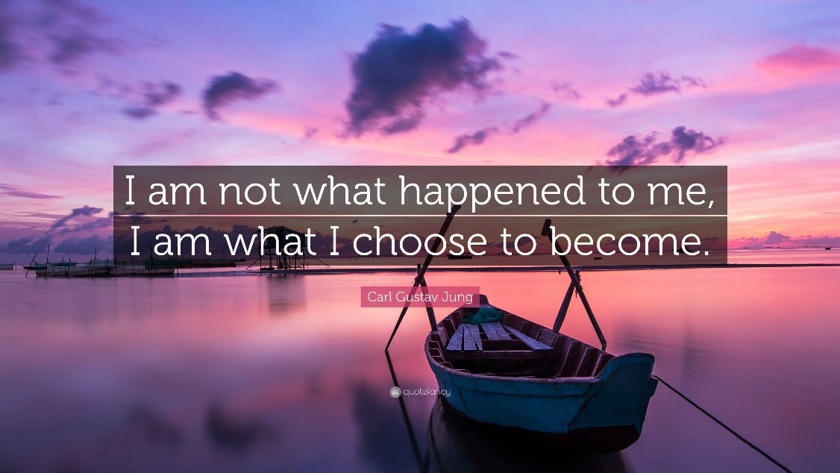

CHAPTER 6: STUMBLING-BLOCKS

Now that you are living the perfect life …. UH OH …. Backspace, delete!

Life is not perfect; people are not perfect. You will fail, fall back into bad habits and feel disappointed. You may even decide that you are incapable of sticking to your resolutions.

That is simply a lie that your mind is telling you. Remember, you have spent your entire life up to this point creating your bad habits. It will take practice to develop good ones. Our brains tell us that how we interpret the input through our senses, is all real, which is a lie. I will repeat this until you believe this, in your heart and mind.

If you are determined to change your bad habits into good ones, it will need perseverance,

DO NOT GIVE UP!

In your workbook, write down each of the stumbling blocks below. Be specific, name examples and people who form part of these. Then add how you intend to overcome each obstacle.

- Regrets

Living with regrets is pointless. You know that. Remind yourself. You cannot undo the past, or erase those cringeworthy moments (like the time I choked and spat coffee all over a stranger’s expensive suit!). Let it go. It just spoils your present moments and really does not add anything positive to your life.

Eleanor Roosevelt said: “It is better to light a candle than to curse the darkness.”

Another statement you may be familiar with, is the one that says ‘Life is 10% about what happens to you and 90% about how you react to that.’

The Wise Man’s Prayer, one of my favorite quotes, states, “Dear Lord, give me the courage to change the things I can, to accept the things I can’t, and give me the wisdom to know the difference.”

Forgive yourself and move on. (Check out the section on Forgiveness below).

- Judgements

Judging others comes so naturally to human nature, and I am no exception. On more than one occasion I have had to do some serious introspection.

Once, I showed a friend of mine a picture on Facebook of an obese woman wearing a crop top and shorts. I asked her, “What was this woman thinking to dress like this?” My friend’s response put my mockery to shame: “Ah, but what confidence she has!”

In the novel, ‘To Kill a Mockingbird’ by Harper Lee, Atticus Finch, a lawyer, must defend a black man who was accused of raping a white woman. The setting is a small town in Southern USA during the 1930s, so prejudice was strong. Atticus tells his young daughter that, in order to understand a person, you have ‘to get into his skin and walk around in it.’

We are all so very different from one another, so one must consciously strive to see matters from another person’s perspective. Maybe that department head who spread lies about me, felt threatened by me?
In one of the couples therapy courses offered by Graham Nicholls, he suggests a method that could assist in creating a distance between yourself and the disagreement with your partner. You state your point of view, then move to a third chair and observe the issue from a stranger’s perspective. That would help two people to gain more insight into, and objectivity towards your differences.

One of my therapy clients was offended by the fact that a friend of hers was buying the exact same products as she was. She actually broke up the friendship, because the friend was copying her in other ways, too. I told her that it was, in actual fact, a compliment – the friend was trying to be like her, because she admired her so much.

Maybe that family member who commented on me not finishing projects spoke from the stance of his own insecurities?

Let me come clean – it was my father. He died in 2017 at the age of 84, quite tranquilly, surrounded by his four daughters, two grandchildren, and sons-in-law. In the ICU, not all at once, of course. He was not an ogre, but as a child, I sometimes perceived him as such.

As an adult, having gone through all these self-searching processes, I have managed to try and understand the person he was at the time when I was growing up. Also, how he grew up. He was the fifth child in a family of six.

Three sons, a daughter, and then two sons. Guess who got the most attention?

His eldest brother became an advocate, the second, a doctor. When he had passed matric, my father went to college to become a teacher. He was always ‘the younger brother’, who did not quite match up with his achiever elder brothers, or there was not enough to pay for higher education. The parents were simple people – his father was a roadworker and his mother a housewife, raising the kids mostly on her own. His pretty older sister was the princess of the house, of course. So, he had insecurities and felt inadequate.

I forgive him for making me the culprit of those. Right now.

- Forgiveness

For the past couple of months, I have been studying Reiki, which is a form of therapy using the energy of the universe to aid healing within yourself or others. The course presenter, Melissa Crowhurst, wrote an amazing blog about forgiveness.

She uses the metaphor of a suitcase. It is a three-step process:

First, pack up all those hurts from the past – put them into a suitcase. You can visualize this in your mind’s eye, or you can physically write down the issues bothering you and put them into a real suitcase or bag.

Second, put the suitcase down.

Third, walk away.

When one puts it like that, it sounds really simple, which it is not. Forgiveness requires effort and willpower. And repetition.

Another technique towards healing could be to write your grudges on slips of paper and stick them into balloons (one piece of paper into each balloon). Release each balloon individually and watch it disappear into the sky, while you visualise your anger and resentment flying off with it.

First and foremost, forgive yourself for not being perfect. No-one is. Perfection is boring, anyway. Be kind to yourself. You are human, you make mistakes, and you learn from them.

Just hold on to this thought: if you keep blaming people for the pain they have caused you in the past, you are constantly reliving it. Moreover, they have no clue about your current pain, and blissfully carry on with their lives, while you are still hashing over their actions (of which they may probably even be unaware, or have forgotten).



Walk away from those old grudges and live your life joyfully! You will be amazed at the sense of relief and freedom that you experience once you have managed to let go.

Another source of comfort I found on social media. A cousin of mine posted this: ‘In order to forgive a person, you don’t have to be present in his or her life.’

This is so very liberating!

In other words, you forgive a person for your own sake, not theirs. It does not mean that you now have to become best buddies with them all of a sudden. There are some people whom I really never want to see in person again.

No grudges? Working on that one.

Albert Einstein said, “Weak people revenge, strong people forgive and intelligent people ignore.”



- Negativity

In South Africa, we are faced with a number of challenges. Since 2020, like the rest of the world, we have had Covid lockdowns, followed by some ridiculous restrictions from the government (a total ban on alcohol and cigarettes).
Social interaction was severely limited, and social distancing was imposed. There was a terror of being infected. Daily newscasts of deaths just aggravated that fear. Furthermore, the weather seemed to be overcast all the time, even throughout the South African summer!

We have had corruption and collapse of infrastructures, ‘load-shedding’ being one of those. This is shutting down electricity for certain periods of the day.

Currently, starting an icy winter, we have up to 11 and a half hours without electricity per day.

Russia’s attack on Ukraine affected the fuel price, which affected the price of commodities. The poor are getting poorer, businesses closing down – it doesn’t seem to have an end!
I am not being callous about the plight of the Ukrainians here; just pointing out the fall-out on my personal situation.
I sincerely pray that those on the streets will be in shelters tonight.

Wherever you are, there will be issues, personal, public, whatever.

It is easy to become negative about whatever is happening, which is the natural tendency of many people.

Groups on Facebook: a person posts something, and the next minute is attacked by the keyboard warriors!

Today the weather was gloomy; we had a particularly bad schedule of load-shedding and my domestic worker was coming in to do the ironing.

My husband has a prostate that needs to be removed, and was going to get his operation date today, which was supposed to be this week.

He sat at the government hospital from 5.30 am until 2pm. His operation date is now scheduled for 18 August, three months from now! His procedure had been declared a “matter of urgency” by the specialist.

It makes you angry, thinking about democracy and its ‘joys’ in our country. Everything has been destroyed, for the advantage of people in power, under the umbrella of “empowerment”. Billions misappropriated.

Change gears.

Negativity serves no purpose.

If you are unhappy about a situation, find ways to change it.

Regarding my husband (options):

- Approach the hospital manager (doctors are on a rotation schedule, so they are not available to an individual)

- Go to the provincial level (mayor, councillors)

- Contact activation groups, political parties.

- Post on social media

- Get the media involved: newspapers, TV

- Contact the WHO, for heavens’ sake! This is not just personal, it is a medical crime!

UPDATE: Perseverance paid off! My husband has been through his surgery and is returning home today, 5 June 2023.

Finally, do this for yourself: Have a journal. Put everything of yourself in there.

But, first of all, every day, place your true gratitude on paper.

That is the very best antidote to negativity. Be grateful for waking up this morning, because many people didn’t. Be grateful for your family, even if they can be a pain.

“Sometimes when you are in a dark place, you think you’ve been buried, but you’ve actually been planted.” Christine Caine

I read the following on LinkedIn this morning. This woman does the following in her journal on a daily basis, about the day before:
She writes down three
- Things that made her happy
- Examples of kindness (by herself or someone else)
- Things that she did well
Doing this should ground you for the day to come, and make you feel positive about yourself.

Dale Carnegie said the following: “Remember, happiness doesn’t depend upon who you are or what you have; it depends solely upon what you think. So start each day by thinking of all the things you have to be thankful for. Your future will depend very largely on the thoughts you think.”
Here is a little story – about me, of course. I was 18 when I was pursued by a fellow student, with whom I became infatuated. I fell pregnant. I told him that I would not consider abortion or adoption, but that he had no obligation to marry me. This was in 1978, so rather conservative times, in a very Afrikaans community.

He insisted on marrying me (very gallant of him), so we did. We graduated, two stunning kids later, and moved to the Eastern Cape where we both had been appointed in teaching posts – he at the co-ed school, and I at a boys’ school.

It was not a good marriage. We were both in our early 20s and completely unequipped for the responsibilities of job, children and marital stress.

In 1983, he came home one day to tell me that he had been having an affair – as a matter of fact, he had been having affairs since we first met, even my roommate at university! The current affair had been ongoing for two years. I was 24. I was willing to continue with the marriage, but my condition was that he had to break it off with the “mistress”. He was not prepared to do so, therefore the children and I moved back to my hometown to live with my father, and to take on a new teaching post at my Alma Mater.

The point of this whole story is this: Once I had settled down, gone through the healing process and had time to think, I realised that an important chunk of my youth was gone. The years between 18 and 25 are those when you set yourself up in life, start your career, spend all your money on clothes and starve for the rest of the month (or go sponge off the parents). It is the time when you go backpacking overseas, do odd jobs when you run out of cash, and come home a far wiser person, ready to settle into suburbandom.

Instead, I had spent those seven valuable years being utterly miserable and feeling unloved, and ended up a divorcee with two dependents. I had some serious life evaluations to do, so I made a list. A list of all the things I would like to have done before I was too old to be able to do them. I only learned later that such a thing is called a ‘bucket list’.

These are some of the wishes/ dreams I listed (not necessarily in order of importance):
- To learn to speak French
- To learn to surf
- To learn to ride a motorbike
- To lose my fear of horses and learn to ride
- To go parachuting
- To write a play, direct it and perform it on stage
- To go bungee jumping

So, how did I do?
- I can speak a little conversational French – importantly, I can order wine, and ask where the station is.
- I practised on a board on the floor in my flat, but, unfortunately, the ocean moves and she doesn’t want you there. Also, doing a Baywatch run down the beach with a seven-foot board if you are 5 ft 7 inches tall, is not really on. When you finally get to where the waves are, after battling through the itty-bitty ones that try to push you back to the beach, you are faced with a queue of 12-year-olds staring at this ancient lady, then lightly hopping onto their boards and zipping to the beach. When it was my turn, I had a row of expectant faces awaiting my performance.
As per the flat floor practice, I hopped onto the board.
And promptly fell off.

I was washed to the beach, and decided that my surfing days were over.

- At the age of 50, I finally learned to ride a 200cc Honda on-offroad motorbike, but never really became proficient.

- I had some students who taught me how to become comfortable with horses, and eventually owned my own.

- I never did. I don’t regret it. I can’t even stand at the edge of a cliff without wanting to plummet downwards. I suppose that is the point of parachuting, but I would probably pass out and forget to pull the cord!

- I was teaching English at an agricultural boys’ high school. These guys were rugby players, tough and beefy. I wrote a murder-mystery play, based on certain activities that the boys got up to in their spare time. I had a cast of 14 boys, performed at the Eisteddfod, and won a silver award!

- I did a bungee! I am just cross that one of the instructors pushed me before the count of four. I would have jumped by myself, honest!

The bottom line of all this is: Make use of your time, in a positive manner. I cannot get back those five years I had frequently spent in abject misery. Because every year, month, hour, and second is over when it is over. FOREVER.
I have to pull myself up short, sometimes, when I do the ‘I wish’ thing – I wish it were holidays, or weekend. THIS is my life! I must not wish it away!

The question is: what are YOU doing with your seconds, hours, months and years in order to fulfill your purpose in life?

I read on LinkedIn about something called the REVERSE bucket list. It is based on the theory that one becomes too emotionally attached to the items on the list and experiences a sense of disappointment once you have achieved them (similar to the goal-setting experience). I would suggest that one should distance oneself from these items emotionally, and rather see them as stepping-stones on the path of realizing your true self.

- Stress

Our lives are so very busy, that we often neglect ourselves. We sit in traffic on the way to work, and more traffic on the way back. People drive inconsiderately, revving up our anger and tension levels. At work, the pressure to perform and get along with colleagues are more stress triggers. Getting home, the wife or husband complains about her/ his day, the kids are being difficult, supper has to be made and so on and so forth.

That is when we make use of crutches for our over-stressed selves, such as alcohol, smoking, taking tablets – anything to make it go away.

Healthy alternatives must be found:

Make time for yourself.
- Write in a journal. This will help the brain to keep record and become aware of repetitive themes. This is only effective when it is kept regularly.
- Meditate.
- Spend time in nature.
- Exercise and eat healthy.
- Look after your body and try to get enough sleep.
- Acquire a creative hobby.
- Talk to your loved ones about your problems, but be careful of using someone as an emotional crutch.
- Join a support group.
- Make time to do nothing.
- Follow a routine and make time for visits and breakaways.
- Talk to a therapist.
(from an article by Luisa van der Linde)

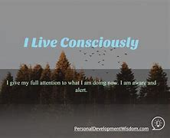

Reiki principles

I mentioned Reiki earlier. One of the fundamental concepts of practising Reiki, is that it comes from a place of love and nurturing.

There are five principles.

Twice a day, repeat the following:

Just for today,

I will not be angry;

I will not worry;

I will be grateful;

I will work with diligence;

I will show love to every living thing.

WORKBOOK

NOTE: You can attach ordinary paper if the space supplied is not enough, or rewrite the questions on separate writing sheets. I suggest you create a file in which you keep your notes. It sometimes helps to revisit your journey.

CHAPTER 1: YOUR PRESENT

- WHY DID YOU BUY THIS BOOK?

…………………………………………………………………………………………

…………………………………………………………………………………………

…………………………………………………………………………………………

…………………………………………………………………………………………

Write the story of your life (use a separate page), highlighting all the issues that have affected you, and that are preventing you from living your best life, or achieving success.

- WHICH EMOTIONS/ BEHAVIOURS DO YOU WANT TO CHANGE?

…………………………………………………………………………………………

…………………………………………………………………………………………

…………………………………………………………………………………………

…………………………………………………………………………………………

- DIG DEEPER INTO THE UNDERLYING EMOTIONS

…………………………………………………………………………………………

…………………………………………………………………………………………

…………………………………………………………………………………………

…………………………………………………………………………………………

- WHICH WORDS DO YOU USE WHEN YOU FEEL THIS WAY?

…………………………………………………………………………………………

…………………………………………………………………………………………

…………………………………………………………………………………………

…………………………………………………………………………………………

CHAPTER 2: YOUR PAST

- WHEN DID YOU FIRST FEEL THIS WAY?

…………………………………………………………………………………………

…………………………………………………………………………………………

…………………………………………………………………………………………

…………………………………………………………………………………………

- REINFORCEMENTS OF THESE FEELINGS

…………………………………………………………………………………………

…………………………………………………………………………………………

…………………………………………………………………………………………

…………………………………………………………………………………………

…………………………………………………………………………………………

…………………………………………………………………………………………

…………………………………………………………………………………………

- WHICH WORDS CAN YOU USE TO REPLACE THOSE FEELINGS?
(Rewrite your negative statements as positive ones)
…………………………………………………………………………………………

…………………………………………………………………………………………

…………………………………………………………………………………………

…………………………………………………………………………………………

…………………………………………………………………………………………

- WRITE YOUR IDENTITY STATEMENT

………………………………………………………………………………………….

………………………………………………………………………………………….

………………………………………………………………………………………….

………………………………………………………………………………………….

- WHO ARE YOUR SUPPORT TEAM MEMBERS?

………………………………………………………………………………………

……………………………………………………………………………………….

……………………………………………………………………………………….

CHAPTER 3: YOUR FUTURE

- VISUALISE YOUR PERFECT SELF

………………………………………………………………………………………..

…………………………………………………………………………………………

…………………………………………………………………………………………

…………………………………………………………………………………………

- MY DREAMS (AND THE REASONS FOR THEM) - you may need lots more space for this, I hope!

THINGS | PERSONAL | OPPORTUNITIES

- EXPERIENCE YOUR EMOTIONS IN YOUR VISUALIZED ENVIRONMENT

…………………………………………………………………………………………

…………………………………………………………………………………………

…………………………………………………………………………………………

…………………………………………………………………………………………

…………………………………………………………………………………………

CHAPTER 4: GETTING THERE

- WHAT DO YOU THINK OF YOUR PRESENT SELF? (Print out this diagram or create a hand-drawn copy)

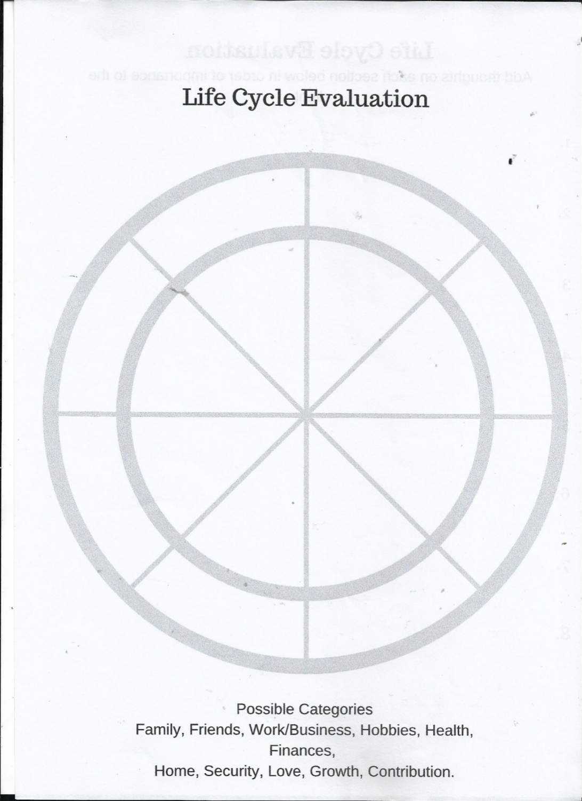

LIST YOUR AREAS OF LIFE FROM THE WEAKEST TO THE STRONGEST:

  - ………………………………………………………………….

  - …………………………………………………………………

  - …………………………………………………………………

  - …………………………………………………………………

  - …………………………………………………………………

  - …………………………………………………………………

  - …………………………………………………………………

  - …………………………………………………………………

- WHAT IS HOLDING YOU BACK? (select your three weakest areas)

2.1………………………………………………………………………………………

2.2………………………………………………………………………………………

2.3………………………………………………………………………………………

- WHAT CAN I DO NOW TO CHANGE THAT?

Create your vision board. Remember to spend two minutes in the mornings and two minutes at night looking at it, feeling it, experiencing it.

List your dreams on a separate piece of paper and select between five and ten of the strongest ones.

- SETTING GOALS

GOAL-SETTING

It is now ………………………………… (month, year).

I have reached my goal …………………………………………………………….

…………………………………………………………………………………………..
(Remember the SMART model)

 | STEPS | RESOURCES | BY WHEN | DONE
 | e.g. To do list | Pen & paper | Today | √
1
2
3
4
5
6
7
8

If you are completing this on your laptop, or if you want to print out this table, please note that you can add rows for more steps by clicking at the bottom of the right-hand column and pressing the TAB button.

The planner above could be used alongside the one below, or they could be used separately. If you have a diary with a monthly planner, you can use that one instead. I like to have a separate planner, which I can file and refer to easily. I transfer the entries from the planner to my diary on a daily basis. It sounds like a lot of admin, but in the end it becomes a habit that flows easily.
I am putting this onto a separate page, so that you can print it out if you want to.
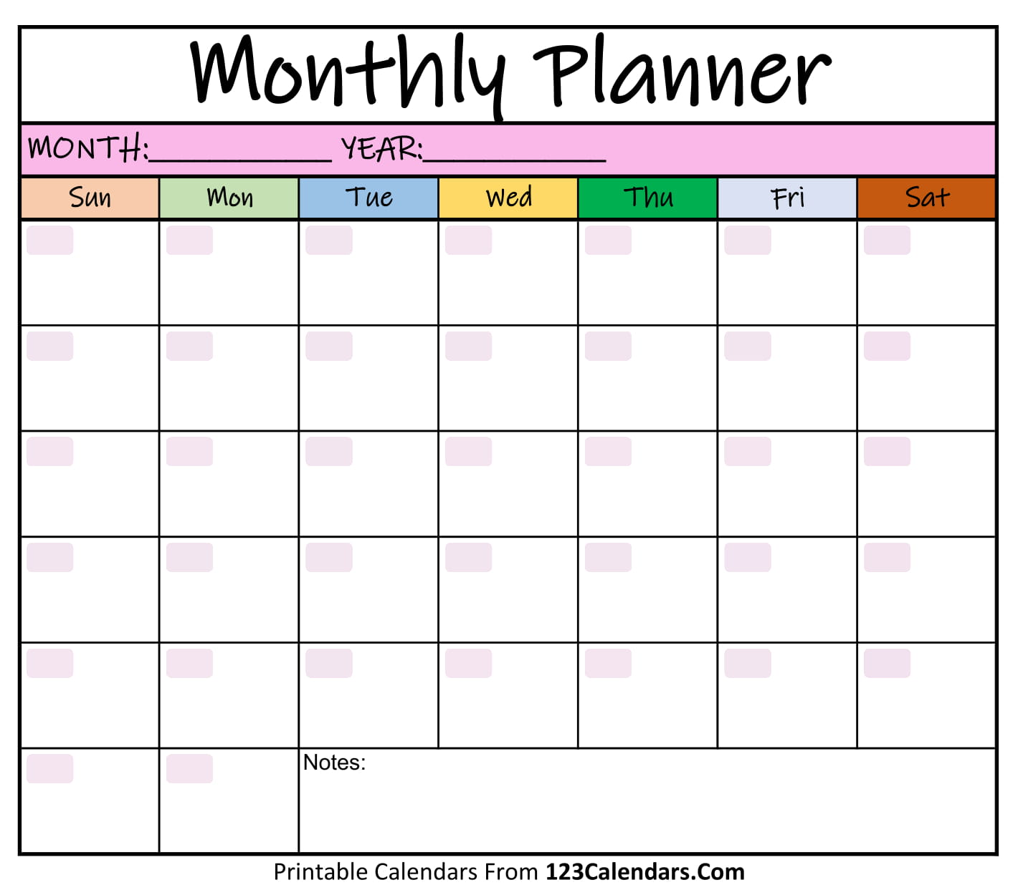
CHAPTER 5: TO DO

STEP 1 My bad habit (s) is/are:

……………………………………………………………………………………

……………………………………………………………………………………

……………………………………………………………………………………

STEP 2: When/why/how you practice it:
……………………………………………………………………………………

……………………………………………………………………………………

……………………………………………………………………………………

STEP 3: What is the positive outcome you want?

…………………………………………………………………………………..

……………………………………………………………………………………

STEP 4: How does the practice of this habit make you feel?

…………………………………………………………………………………..

……………………………………………………………………………………

STEP 5: Are there any other options for this habit to gain the feelings you want?

……………………………………………………………………………………

……………………………………………………………………………………

STEP 6: Reminders/ alerts to stop bad habit:

……………………………………………………………………………………

……………………………………………………………………………………

CHAPTER 6: STUMBLING-BLOCKS

- Regrets:

……………………………………………………………………………

……………………………………………………………………………

……………………………………………………………………………

How do I overcome these?

……………………………………………………………………………

……………………………………………………………………………

- Judgements: Whom do I judge and why?

……………………………………………………………………………

……………………………………………………………………………

How am I going to stop judging others?

……………………………………………………………………………

……………………………………………………………………………

- Forgiveness: Whom do I need to forgive and why (what have they done to me that needs forgiveness)?

……………………………………………………………………………

……………………………………………………………………………

……………………………………………………………………………

……………………………………………………………………………

Go through the three-step process with each person you need to forgive, or use the balloon method, or both.

- Negativity: Which situations, people or events make you feel negative?

……………………………………………………………………………

……………………………………………………………………………

……………………………………………………………………………

How are you going to prevent or counteract negative feelings in these cases?

……………………………………………………………………………

……………………………………………………………………………

……………………………………………………………………………

- Stress

Which situations trigger your stress levels?

……………………………………………………………………………

…………………………………………………………………………….

……………………………………………………………………………..

Which alternatives are you going to adopt in order to defuse your stress? (you can use the ones mentioned, or add your own).

……………………………………………………………………………

……………………………………………………………………………

……………………………………………………………………………

……………………………………………………………………………

Remember that this process is not a once-off, foolproof method towards perfection. This is a coping mechanism to assist you in dealing with issues you may encounter, to help you achieve your dreams and aspirations. You may have to refer to this book and your notes repeatedly, so keep it somewhere you can find it easily.
The intention is to guide you towards living a happy, successful present, working towards a fabulous future, and freeing yourself of the shackles of the past.
Bon voyage!

